Installing SQLite3 on Windows:

1. First, go to the [https://www.sqlite.org](https://www.sqlite.org/) website.

2. Second, open the download page <https://www.sqlite.org/download.html>

SQLite provides various versions for various platforms e.g., Windows, Linux, Mac, etc. You should choose an appropriate version to download.

For example, to work with SQLite on Windows, you download the command-line shell program as shown in the screenshot below. 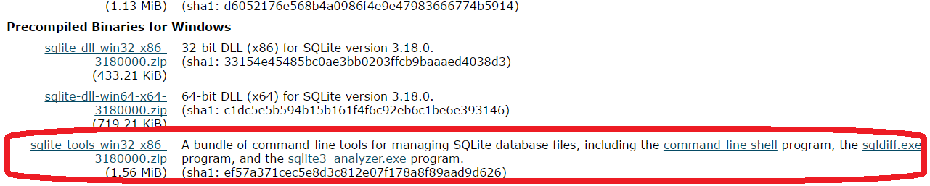

The downloaded file is ZIP format

3. First, create a new folder e.g., C:\Users\Shiv\sqlite

4. Second, extract the content of the file that you downloaded in the previous section to the C:\Users\Shiv\sqlite folder.

To verify the installation, you perform the following steps: First, open the command line window and navigate to the C:\Users\Shiv\sqlite folder.

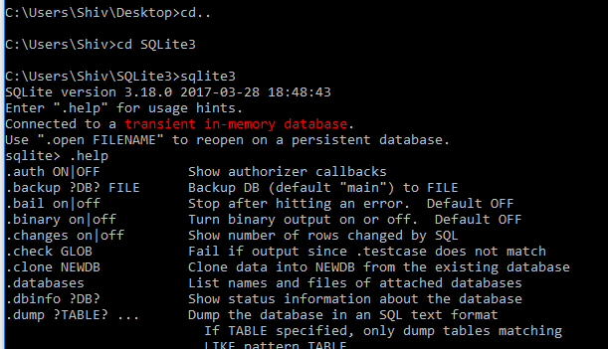

Before using it in Jupyter notebook we need to make sure that the path is added to system path:

1. Right click on “This PC” and select “Properties”

2. Click on Advanced setting:

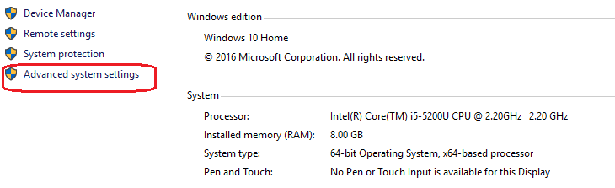

3. Select Environment Variables:

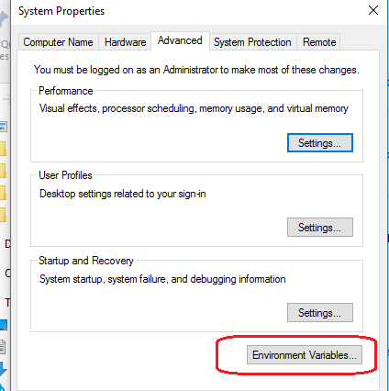

4. Select Path Edit:

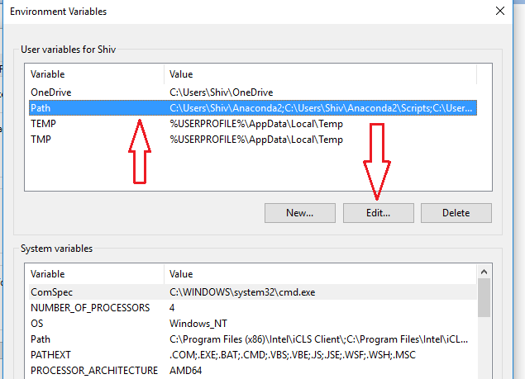

5. In Edit Environment Variables window click on New and Add the path, make sure there is no space on the left side of the path while pasting it in this tab.

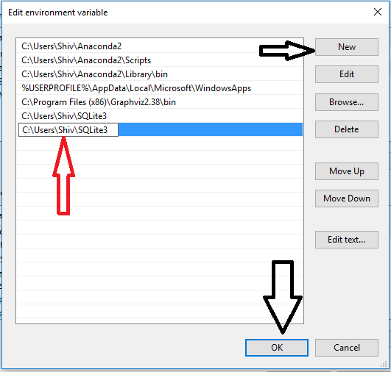

6. While exiting don’t forget to click on OK:

